# Setting Up a Zabbix Monitoring System on Ubuntu 20.04

## Step 1: Update and Upgrade

sudo apt update

sudo apt upgrade -y

## Step 2: Install MySQL Server

sudo apt install mysql-server

sudo systemctl start mysql.service

mysql_secure_installation

## Step 3: Install Zabbix Repository

wget https://repo.zabbix.com/zabbix/6.0/ubuntu/pool/main/z/zabbix-release/zabbix-release_6.0-4+ubuntu20.04_all.deb

sudo dpkg -i zabbix-release_6.0-4+ubuntu20.04_all.deb

## Step 4: Install Zabbix Components

sudo apt update

sudo apt install zabbix-server-mysql zabbix-frontend-php zabbix-apache-conf zabbix-sql-scripts zabbix-agent

## Step 5: Configure Zabbix MySQL Database

mysql -uroot -p

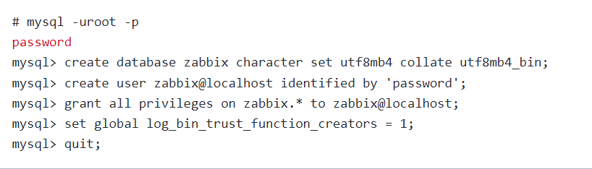

CREATE DATABASE zabbix CHARACTER SET utf8mb4 COLLATE utf8mb4_general_ci;

CREATE USER 'zabbix'@'localhost' IDENTIFIED BY 'your_password';

GRANT ALL PRIVILEGES ON zabbix.* TO 'zabbix'@'localhost';

FLUSH PRIVILEGES;

QUIT;

## Step 6: Import Zabbix Database Schema

zcat /usr/share/zabbix-sql-scripts/mysql/server.sql.gz | mysql --default-character-set=utf8mb4 -uzabbix -p Zabbix

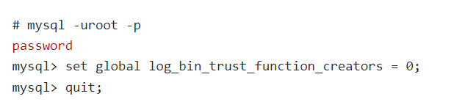

## Step 7: Configure Zabbix Server

sudo nano /etc/zabbix/zabbix_server.conf

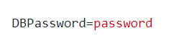

**In the configuration file, modify the DBPassword parameter with the password you set for the Zabbix MySQL user.**

## Step 8: Start Zabbix Services

sudo systemctl restart zabbix-server zabbix-agent apache2

sudo systemctl enable zabbix-server zabbix-agent apache2

## Step 9: Access the Zabbix Web Interface

Open a web browser and enter your server's IP address or domain followed by /zabbix. You'll be prompted to set up the Zabbix front end.

Follow the web-based installation wizard to configure your Zabbix front end, providing necessary information like database details, admin credentials, and server settings.

### Welcome screen

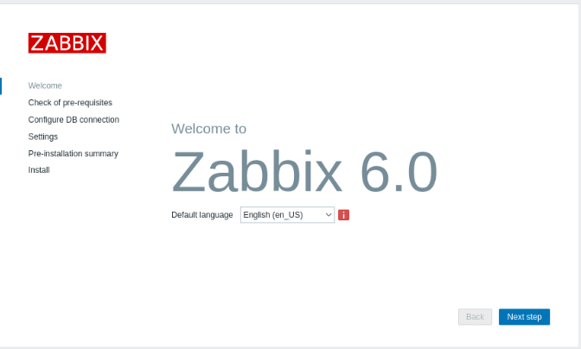

### Check of pre-requisites

Make sure that all software prerequisites are met.

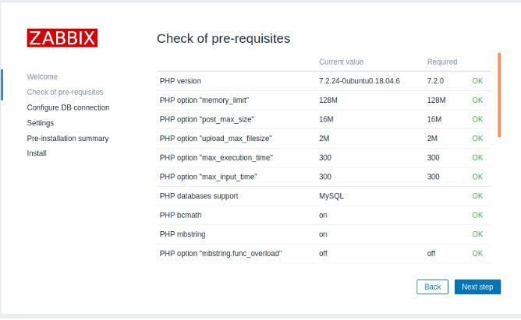

### Configure DB connection

Enter details for connecting to the database. Zabbix database must already be created.

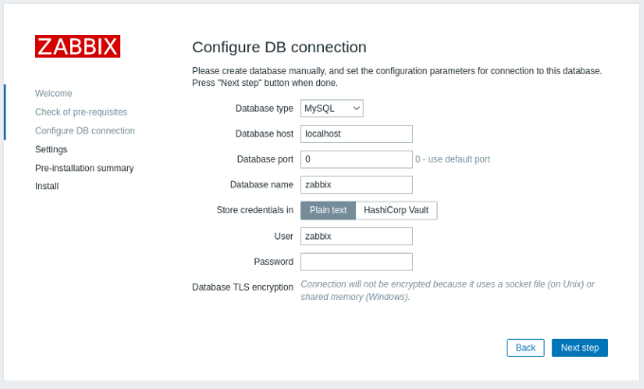

### Settings

Entering a name for Zabbix server is optional, however, if submitted, it will be displayed in the menu bar and page titles.

Set the default [time zone](https://www.zabbix.com/documentation/6.0/en/manual/web_interface/time_zone#overview) and theme for the frontend.

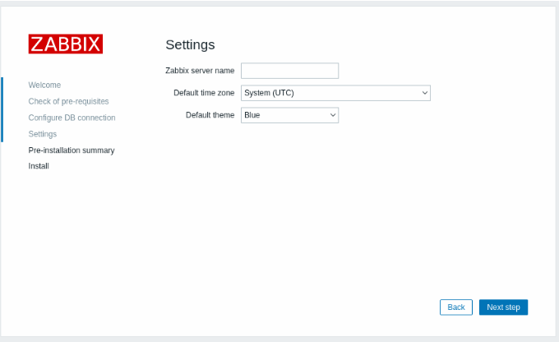

### Pre-installation summary

Review a summary of settings.

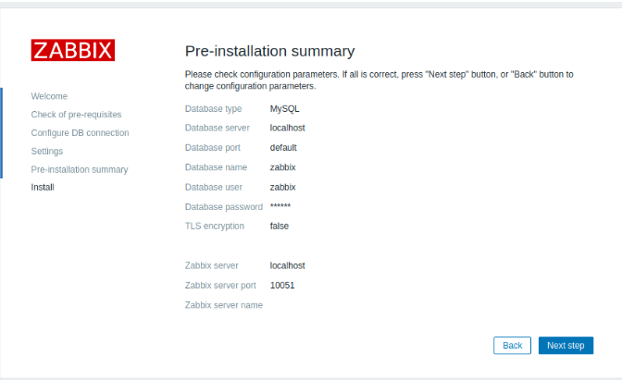

### Finish the installation.

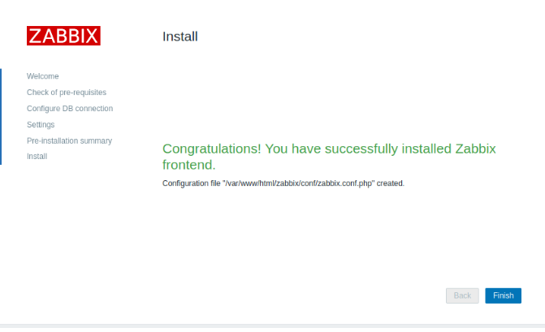

### Log in

Zabbix frontend is ready! The default user name is **Admin**, password **zabbix**.

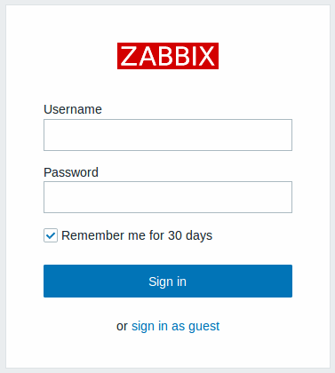

Once the installation is complete, you should have a functioning Zabbix monitoring system accessible through your web browser.